UNITED STATES
SECURITIES AND EXCHANGE COMMISSION
Washington, D.C. 20549
___________________________________________
FORM 8-K
___________________________________________
CURRENT REPORT
Pursuant to Section 13 or 15(d)
of the Securities Exchange Act of 1934
Date of Report (Date of earliest event reported): July 15, 2026
___________________________________________
ARCUTIS BIOTHERAPEUTICS, INC.
(Exact name of registrant as specified in its charter)
___________________________________________
Delaware |  |  | 001-39186 |  |  | 81-2974255
(State or other jurisdiction  of incorporation) |  |  | (Commission  File Number) |  |  | (IRS Employer  Identification Number)
3027 Townsgate Road, Suite300
Westlake Village, CA 91361
(Address of principal executive offices, including Zip Code)
Registrant’s telephone number, including area code: (805) 418-5006
___________________________________________
Check the appropriate box below if the Form 8-K filing is intended to simultaneously satisfy the filing obligation of the registrant under any of the following provisions (see General Instructions A.2. below):
☐ |  |  | Written communications pursuant to Rule 425 under the Securities Act (17 CFR 230.425)
☐ |  |  | Soliciting material pursuant to Rule 14a-12 under the Exchange Act (17 CFR 240.14a-12)
☐ |  |  | Pre-commencement communications pursuant to Rule 14d-2(b) under the Exchange Act (17 CFR 240.14d-2(b))
☐ |  |  | Pre-commencement communications pursuant to Rule 13e-4(c) under the Exchange Act (17 CFR 240.13e-4(c))
Securities registered pursuant to Section 12(b) of the Act:
Title of each class |  |  |  |  |  | Trading  Symbol(s) |  |  |  |  |  | Name of each exchange  on which registered
Common Stock, par value $0.0001 per share |  |  |  |  |  | ARQT |  |  |  |  |  | The Nasdaq Global Select Market
Indicate by check mark whether the registrant is an emerging growth company as defined in Rule 405 of the Securities Act of 1933 (§ 230.405 of this chapter) or Rule 12b-2 of the Securities Exchange Act of 1934 (§ 240.12b-2 of this chapter). Emerging growth company ☐
If an emerging growth company, indicate by check mark if the registrant has elected not to use the extended transition period for complying with any new or revised financial accounting standards provided pursuant to Section 13(a) of the Exchange Act. ☐

Item 5.02 |  |  | Departure of Directors or Certain Officers; Election of Directors; Appointment of Certain Officers; Compensatory Arrangements of Certain Officers.
On July 15, 2026, the Board of Directors (the “Board”) of Arcutis Biotherapeutics, Inc. (the “Company”) increased the authorized number of directors on the Board from nine to ten directors and appointed Mr. Christopher Peetz as a new member of the Board. Mr. Peetz was appointed as a Class III director, with a term expiring at the Company’s 2029 annual meeting of stockholders or until his successor is duly elected and qualified, or his earlier death, resignation, disqualification or removal. The Board determined that Mr. Peetz qualifies as an independent director under the applicable rules and regulations of the Securities and Exchange Commission and the listing standards of The Nasdaq Stock Market LLC. Mr. Peetz has not been appointed to any committee of the Board.

Mr. Peetz is a co-founder of Mirum Pharmaceuticals, Inc., a commercial-stage biopharmaceutical company, where he has served as Chief Executive Officer since March 2019 and as President from November 2018 to January 2024. Prior to Mirum Pharmaceuticals, Inc., Mr. Peetz served as Chief Executive Officer of Flashlight Therapeutics, Inc., a biotechnology company, from May 2017 to May 2019. He also previously served as Chief Financial Officer and head of corporate development at Tobira Therapeutics, Inc., a publicly-traded biotechnology company acquired by Allergan plc. in November 2016, from May 2014 to December 2016. Prior to joining Tobira Therapeutics, Inc, Mr. Peetz served as Vice President, Finance and Corporate Development of Jennerex Biotherapeutics, Inc., a biopharmaceutical company. Prior to Jennerex, Mr. Peetz held various positions at Onyx Pharmaceuticals, Inc. (now Amgen Inc.), including corporate strategy, marketing, product lifecycle management, and financial planning. Prior to Onyx, Mr. Peetz provided merger and acquisition advisory services at LaSalle Corporate Finance, a part of ABN AMRO, and held positions at Abgenix Inc. and Solazyme Inc. He also served as a member of the board of directors of Alpine Immune Sciences, Inc., a public immunotherapy company, from April 2018 until its sale to Vertex in May 2024. Mr. Peetz has been an entrepreneur-in-residence at Frazier Life Sciences since May 2017. Mr. Peetz received an M.B.A. from Stanford Graduate School of Business and a B.S.B.A. in finance, international business, and French from Washington University in St. Louis.

As a non-employee director, Mr. Peetz will receive compensation in accordance with the Company’s non-employee director compensation program, as amended. Pursuant to this program, upon the effective date of his appointment to the Board, Mr. Peetz received an initial stock option award exercisable for 21,486 shares of the Company’s common stock, and is eligible for the prorated annual equity award fair valued at approximately $350,000 (allocated 65% to stock options and 35% to restricted stock units) and for the prorated portion of the annual cash retainer in the amount of $50,000 for service on the Board. The initial stock option award will vest in three equal annual installments on the anniversary of the date of Mr. Peetz’s appointment to the Board, and the prorated annual equity award immediately before the annual meeting following the grant date, subject to Mr. Peetz’s continued service to the Company through such date.

In addition, the Company will enter into an indemnification agreement with Mr. Peetz on the form previously approved by the Board and entered into with the Company’s other directors.

There is no arrangement or understanding between Mr. Peetz and any other person pursuant to which he was selected as a director. There are no family relationships between Mr. Peetz and any of the Company’s directors or executive officers. There are no transactions to which the Company is a party and in which Mr. Peetz has a direct or indirect material interest that would be required to be disclosed under Item 404(a) of Regulation S-K.

Item 7.01 Regulation FD Disclosure.

On July 16, 2026, the Company issued a press release announcing the appointment of Mr. Peetz. A copy of the press release is attached hereto as Exhibit 99.1.

The information contained in this Item 7.01 and Exhibit 99.1 hereto shall not be deemed “filed” for purposes of Section 18 of the Securities Exchange Act of 1934, as amended (the "Exchange Act”), or otherwise subject to the liabilities of that section, nor shall it be deemed incorporated by reference into any other filing under the Securities Act of 1933, as amended, or the Exchange Act, except as expressly set forth by specific reference in such a filing.

Item 9.01 |  |  | Financial Statements and Exhibits.
(d) Exhibits

Exhibit No. |  |  |  |  |  | Description
99.1 |  |  |  |  |  | Arcutis Biotherapeutics Inc. Appoints Christopher Peetz to Board of Directors.
104 |  |  |  |  |  | Cover Page Interactive Data File (embedded within the Inline XBRL document)

SIGNATURES
Pursuant to the requirements of the Securities Exchange Act of 1934, as amended, the registrant has duly caused this report to be signed on its behalf by the undersigned hereunto duly authorized.

 |  |  |  |  |  | ARCUTIS BIOTHERAPEUTICS, INC.
Date: July 16, 2026 |  |  |  |  |  | By: |  |  | /s/ Latha Vairavan
Latha Vairavan
Chief Financial Officer

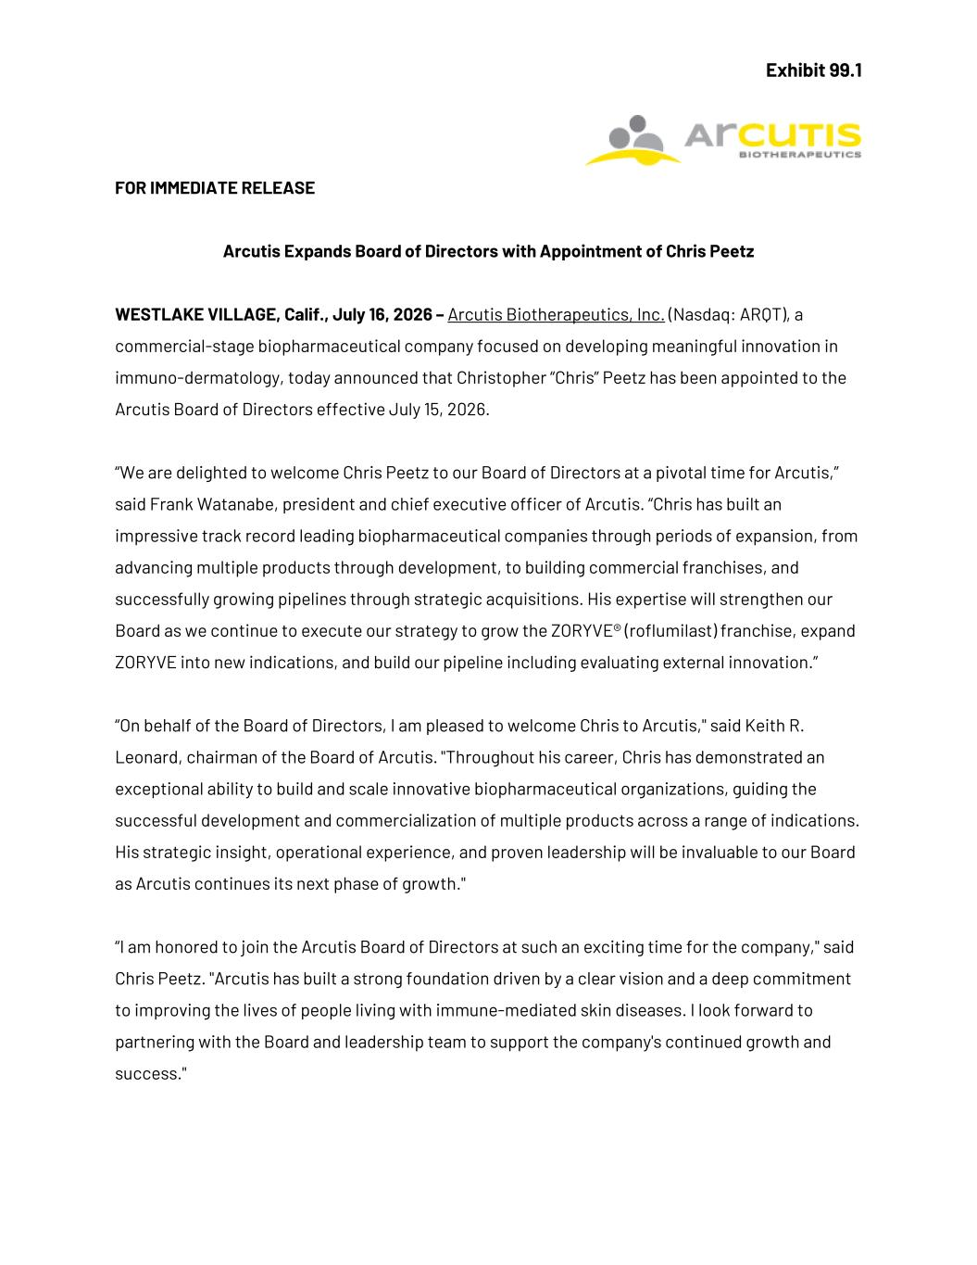

Exhibit 99.1 FOR IMMEDIATE RELEASE Arcutis Expands Board of Directors with Appointment of Chris Peetz WESTLAKE VILLAGE, Calif., July 16, 2026 – Arcutis Biotherapeutics, Inc. (Nasdaq: ARQT), a commercial-stage biopharmaceutical company focused on developing meaningful innovation in immuno-dermatology, today announced that Christopher “Chris” Peetz has been appointed to the Arcutis Board of Directors effective July 15, 2026. “We are delighted to welcome Chris Peetz to our Board of Directors at a pivotal time for Arcutis,” said Frank Watanabe, president and chief executive officer of Arcutis. “Chris has built an impressive track record leading biopharmaceutical companies through periods of expansion, from advancing multiple products through development, to building commercial franchises, and successfully growing pipelines through strategic acquisitions. His expertise will strengthen our Board as we continue to execute our strategy to grow the ZORYVE® (roflumilast) franchise, expand ZORYVE into new indications, and build our pipeline including evaluating external innovation.” “On behalf of the Board of Directors, I am pleased to welcome Chris to Arcutis," said Keith R. Leonard, chairman of the Board of Arcutis. "Throughout his career, Chris has demonstrated an exceptional ability to build and scale innovative biopharmaceutical organizations, guiding the successful development and commercialization of multiple products across a range of indications. His strategic insight, operational experience, and proven leadership will be invaluable to our Board as Arcutis continues its next phase of growth." “I am honored to join the Arcutis Board of Directors at such an exciting time for the company," said Chris Peetz. "Arcutis has built a strong foundation driven by a clear vision and a deep commitment to improving the lives of people living with immune-mediated skin diseases. I look forward to partnering with the Board and leadership team to support the company's continued growth and success."

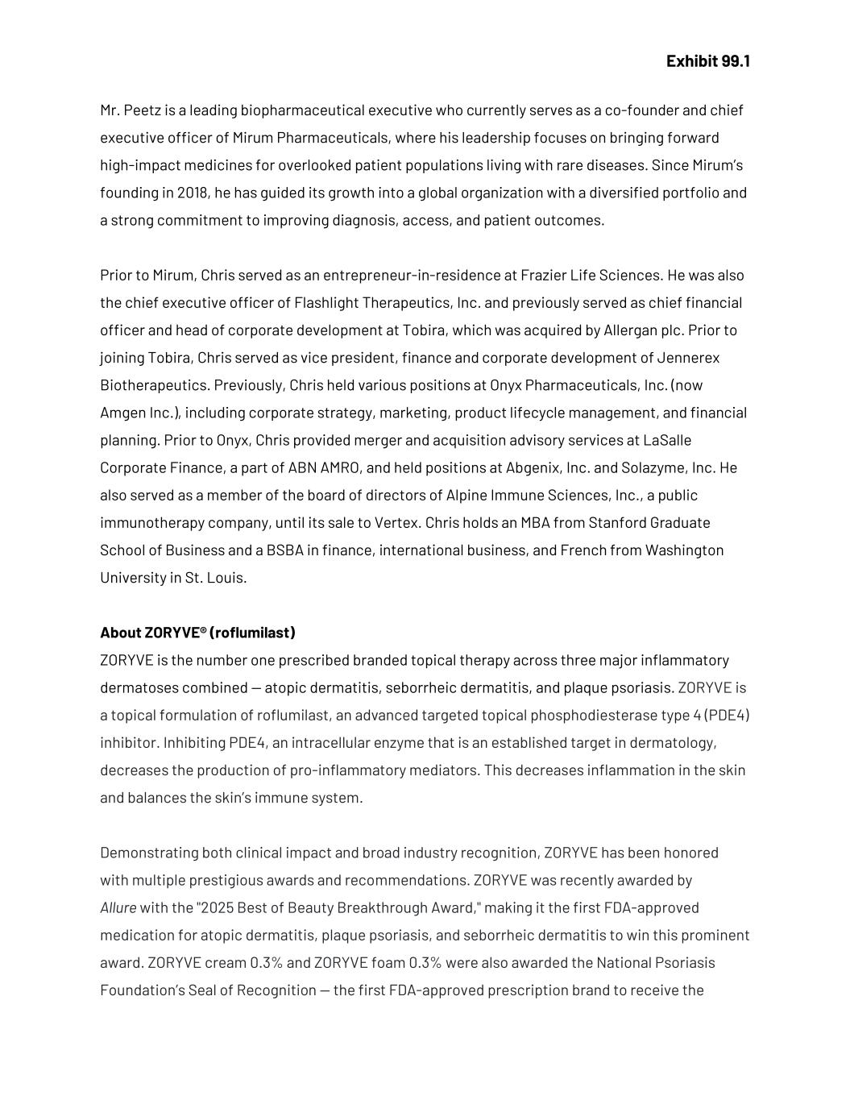
Exhibit 99.1 Mr. Peetz is a leading biopharmaceutical executive who currently serves as a co-founder and chief executive officer of Mirum Pharmaceuticals, where his leadership focuses on bringing forward high-impact medicines for overlooked patient populations living with rare diseases. Since Mirum’s founding in 2018, he has guided its growth into a global organization with a diversified portfolio and a strong commitment to improving diagnosis, access, and patient outcomes. Prior to Mirum, Chris served as an entrepreneur-in-residence at Frazier Life Sciences. He was also the chief executive officer of Flashlight Therapeutics, Inc. and previously served as chief financial officer and head of corporate development at Tobira, which was acquired by Allergan plc. Prior to joining Tobira, Chris served as vice president, finance and corporate development of Jennerex Biotherapeutics. Previously, Chris held various positions at Onyx Pharmaceuticals, Inc. (now Amgen Inc.), including corporate strategy, marketing, product lifecycle management, and financial planning. Prior to Onyx, Chris provided merger and acquisition advisory services at LaSalle Corporate Finance, a part of ABN AMRO, and held positions at Abgenix, Inc. and Solazyme, Inc. He also served as a member of the board of directors of Alpine Immune Sciences, Inc., a public immunotherapy company, until its sale to Vertex. Chris holds an MBA from Stanford Graduate School of Business and a BSBA in finance, international business, and French from Washington University in St. Louis. About ZORYVE® (roflumilast) ZORYVE is the number one prescribed branded topical therapy across three major inflammatory dermatoses combined — atopic dermatitis, seborrheic dermatitis, and plaque psoriasis. ZORYVE is a topical formulation of roflumilast, an advanced targeted topical phosphodiesterase type 4 (PDE4) inhibitor. Inhibiting PDE4, an intracellular enzyme that is an established target in dermatology, decreases the production of pro-inflammatory mediators. This decreases inflammation in the skin and balances the skin’s immune system. Demonstrating both clinical impact and broad industry recognition, ZORYVE has been honored with multiple prestigious awards and recommendations. ZORYVE was recently awarded by Allure with the "2025 Best of Beauty Breakthrough Award," making it the first FDA-approved medication for atopic dermatitis, plaque psoriasis, and seborrheic dermatitis to win this prominent award. ZORYVE cream 0.3% and ZORYVE foam 0.3% were also awarded the National Psoriasis Foundation’s Seal of Recognition — the first FDA-approved prescription brand to receive the

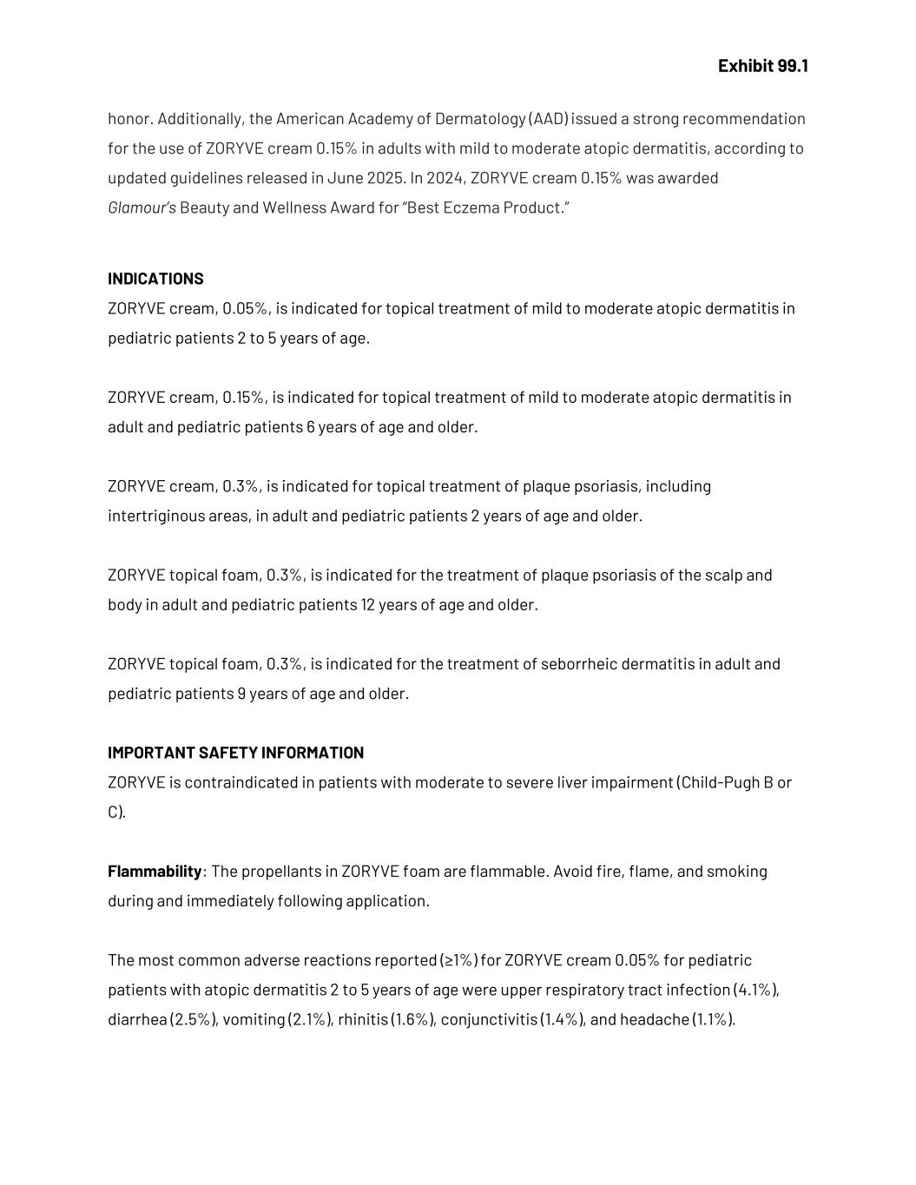
Exhibit 99.1 honor. Additionally, the American Academy of Dermatology (AAD) issued a strong recommendation for the use of ZORYVE cream 0.15% in adults with mild to moderate atopic dermatitis, according to updated guidelines released in June 2025. In 2024, ZORYVE cream 0.15% was awarded Glamour’s Beauty and Wellness Award for “Best Eczema Product.” INDICATIONS ZORYVE cream, 0.05%, is indicated for topical treatment of mild to moderate atopic dermatitis in pediatric patients 2 to 5 years of age. ZORYVE cream, 0.15%, is indicated for topical treatment of mild to moderate atopic dermatitis in adult and pediatric patients 6 years of age and older. ZORYVE cream, 0.3%, is indicated for topical treatment of plaque psoriasis, including intertriginous areas, in adult and pediatric patients 2 years of age and older. ZORYVE topical foam, 0.3%, is indicated for the treatment of plaque psoriasis of the scalp and body in adult and pediatric patients 12 years of age and older. ZORYVE topical foam, 0.3%, is indicated for the treatment of seborrheic dermatitis in adult and pediatric patients 9 years of age and older. IMPORTANT SAFETY INFORMATION ZORYVE is contraindicated in patients with moderate to severe liver impairment (Child-Pugh B or C). Flammability: The propellants in ZORYVE foam are flammable. Avoid fire, flame, and smoking during and immediately following application. The most common adverse reactions reported (≥1%) for ZORYVE cream 0.05% for pediatric patients with atopic dermatitis 2 to 5 years of age were upper respiratory tract infection (4.1%), diarrhea (2.5%), vomiting (2.1%), rhinitis (1.6%), conjunctivitis (1.4%), and headache (1.1%).

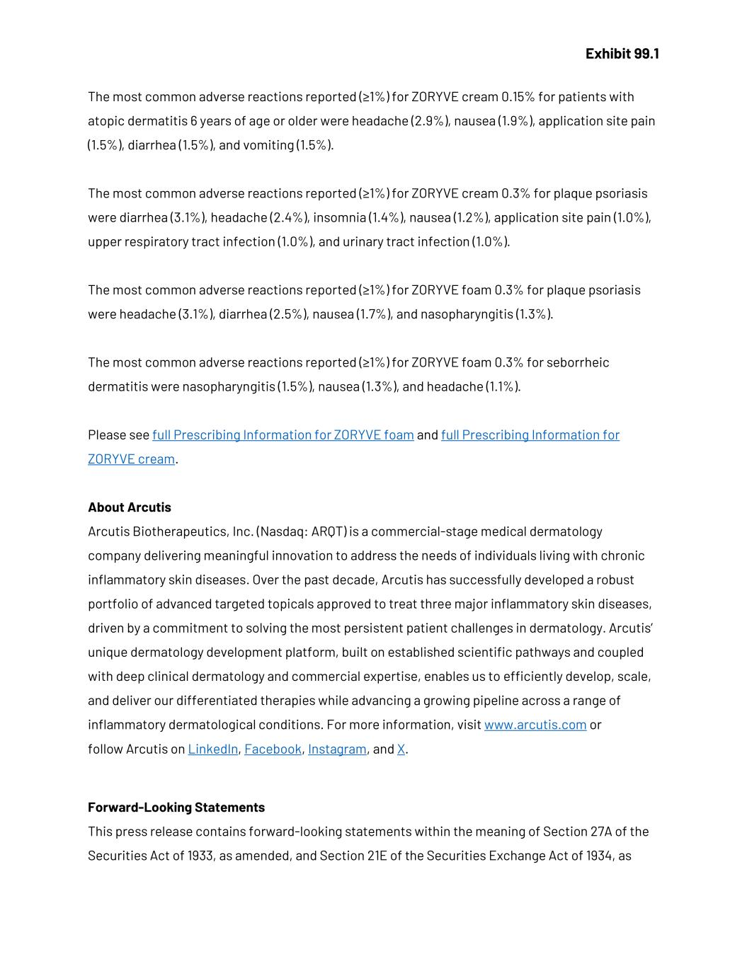
Exhibit 99.1 The most common adverse reactions reported (≥1%) for ZORYVE cream 0.15% for patients with atopic dermatitis 6 years of age or older were headache (2.9%), nausea (1.9%), application site pain (1.5%), diarrhea (1.5%), and vomiting (1.5%). The most common adverse reactions reported (≥1%) for ZORYVE cream 0.3% for plaque psoriasis were diarrhea (3.1%), headache (2.4%), insomnia (1.4%), nausea (1.2%), application site pain (1.0%), upper respiratory tract infection (1.0%), and urinary tract infection (1.0%). The most common adverse reactions reported (≥1%) for ZORYVE foam 0.3% for plaque psoriasis were headache (3.1%), diarrhea (2.5%), nausea (1.7%), and nasopharyngitis (1.3%). The most common adverse reactions reported (≥1%) for ZORYVE foam 0.3% for seborrheic dermatitis were nasopharyngitis (1.5%), nausea (1.3%), and headache (1.1%). Please see full Prescribing Information for ZORYVE foam and full Prescribing Information for ZORYVE cream. About Arcutis Arcutis Biotherapeutics, Inc. (Nasdaq: ARQT) is a commercial-stage medical dermatology company delivering meaningful innovation to address the needs of individuals living with chronic inflammatory skin diseases. Over the past decade, Arcutis has successfully developed a robust portfolio of advanced targeted topicals approved to treat three major inflammatory skin diseases, driven by a commitment to solving the most persistent patient challenges in dermatology. Arcutis’ unique dermatology development platform, built on established scientific pathways and coupled with deep clinical dermatology and commercial expertise, enables us to efficiently develop, scale, and deliver our differentiated therapies while advancing a growing pipeline across a range of inflammatory dermatological conditions. For more information, visit www.arcutis.com or follow Arcutis on LinkedIn, Facebook, Instagram, and X. Forward-Looking Statements This press release contains forward-looking statements within the meaning of Section 27A of the Securities Act of 1933, as amended, and Section 21E of the Securities Exchange Act of 1934, as

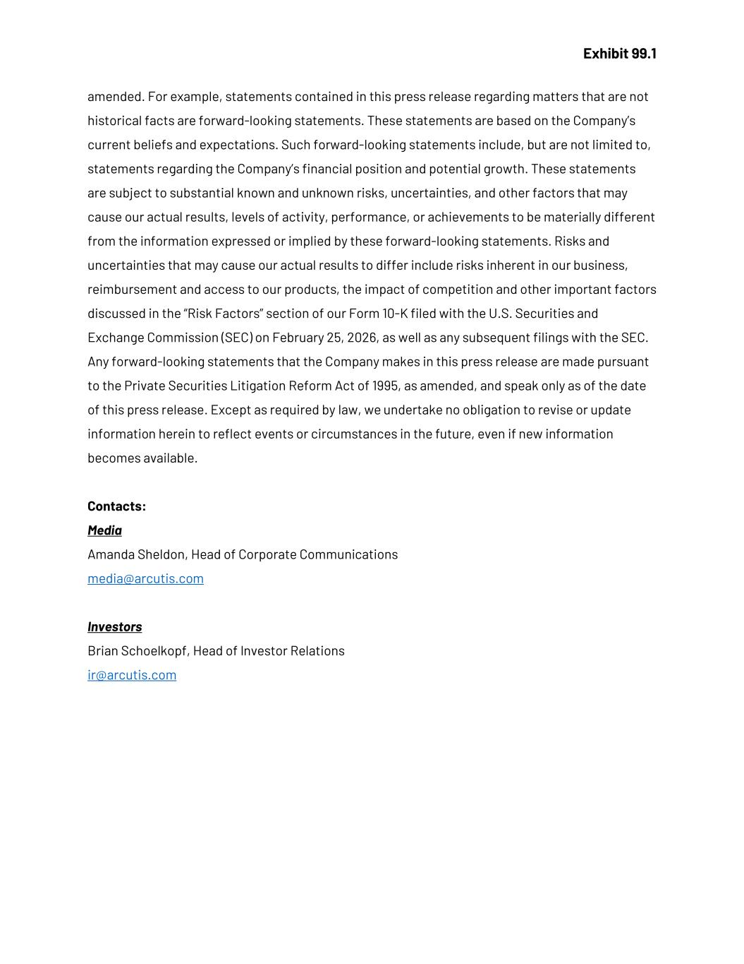
Exhibit 99.1 amended. For example, statements contained in this press release regarding matters that are not historical facts are forward-looking statements. These statements are based on the Company’s current beliefs and expectations. Such forward-looking statements include, but are not limited to, statements regarding the Company’s financial position and potential growth. These statements are subject to substantial known and unknown risks, uncertainties, and other factors that may cause our actual results, levels of activity, performance, or achievements to be materially different from the information expressed or implied by these forward-looking statements. Risks and uncertainties that may cause our actual results to differ include risks inherent in our business, reimbursement and access to our products, the impact of competition and other important factors discussed in the “Risk Factors” section of our Form 10-K filed with the U.S. Securities and Exchange Commission (SEC) on February 25, 2026, as well as any subsequent filings with the SEC. Any forward-looking statements that the Company makes in this press release are made pursuant to the Private Securities Litigation Reform Act of 1995, as amended, and speak only as of the date of this press release. Except as required by law, we undertake no obligation to revise or update information herein to reflect events or circumstances in the future, even if new information becomes available. Contacts: Media Amanda Sheldon, Head of Corporate Communications media@arcutis.com Investors Brian Schoelkopf, Head of Investor Relations ir@arcutis.com

